***Part 1:*** *Computing Fundamentals*

**1**

**Field Guide to Identifying Computers in the Wild**

CHAPTER 1:

TO IDENTIFYING COMPUTERS IN THE WILD

“You know, like nunchuck skills, bowhunting skills, computer hacking skills . . . girls only want boyfriends who have great skills.”

– Napoleon Dynamite, *Napoleon Dynamite*

This chapter covers the following IC3 exam objectives:

FIELD GUIDE

|  |  |  |
| --- | --- | --- |
| * IC3-1 | 1.1.1 | Categorize types of computers based on their size, power, and purpose |
| * IC3-1 | 1.1.2 | Identify types of microcomputers |
| * IC3-1 | 1.1.3 | Identify other computing devices |
| * IC3-1 | 1.1.4 | Identify the role of the central processing unit |
| * IC3-1 | 1.1.9 | Identify the differences between large systems (such as mainframe or mini-computer systems with centralized data processing and storage) and desktop computers and appropriate uses for large vs. small systems |
| * IC3-1 | 1.1.10 | Identify how computers integrate into larger systems |
| * IC3-1 | 1.1.11 | Identify how computers share data, files, hardware and software |

I grew up watching movies. Like a lot of computer geeks, science fiction and futuristic spy thrillers are my favorites. I like the gadgets. I like the ray guns, the spaceships, the robot monkey butlers, and especially the computers.

Of course, the movies aren’t always the most reliable place to go for accu- rate portrayals of computer technology. If we’re to believe what we see in the movies, for example, computers of the future are always on the verge of declaring, “I think, therefore I am” and taking over the world. Luckily, these futuristic computers can usually be shut down by means of a manual override switch conveniently located over a bottomless pit.

Well, we’re over 1/20th of the way into the 21st century, so it’s safe to say that the future is here. What are the computers of the future really like? William Gibson, the author of the classic sci-fi book Neuromancer, once com- mented that he thought the computer of the future would be invisible. Not in the literal sense that you wouldn’t be able to see them, but invisible in the sense that they’d be so commonplace that you’d take no notice of them. Guess what? We’re almost there!

**3**

**3**

CHAPTER 1: FIELD GUIDE TO IDENTIFYING COMPUTERS IN THE WILD

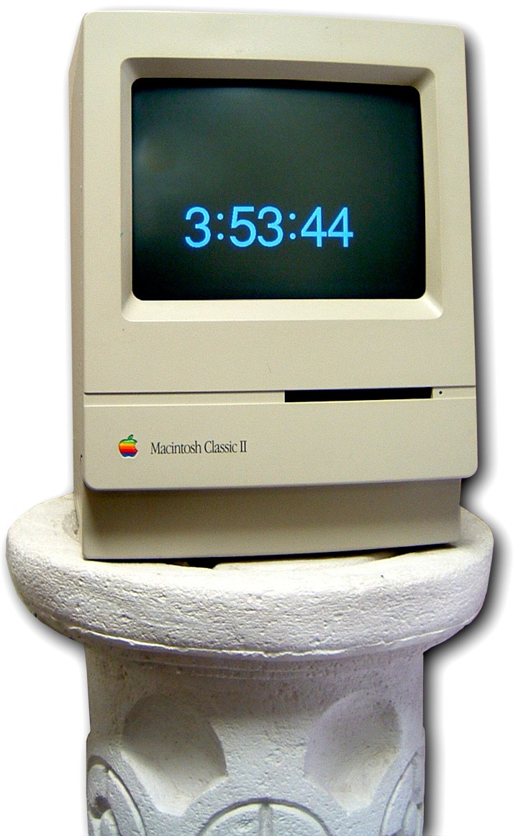

*Figure 1.1: Hey! There’s a computer in my clock!*

*Figure 1.2: Early use for computers (Courtesy of the Bibliothèque nationale de France)*

# *It’s a Wired World*

Computers are everywhere: in our homes, in our offices, in our businesses, schools, and libraries. Not just in the usual sense, meaning the desktop or laptop personal computer (PC) that you’re used to seeing, but in many differ- ent forms, performing many different functions (Figure 1.1). Do you use TiVo? It’s a kind of computer. Got an iPod? Another computer. If your car was built in the last twenty years or so, it has at least one computer on board, and probably more than one in the form of navigation equipment, audio and video players, and so on. Computers control much of the manufacturing processes in almost every facility in the United States, helping people produce everything from toys to life-saving medical equipment. Even in places you don’t normally see, you’ll find computers at the heart. Given that so many devices can be called a computer, what exactly does the term mean?

In this chapter, I want to discuss the various types of computers and other computing devices that are out there in the world, identify the different pur- poses of these computer systems, and talk about how computers integrate and share *data*—the files stored on the computer. I’m going to start with a brief discussion of what computers are and what they do, and look at the means we use to interact with them. Let’s get started.

## An Exceedingly Brief History of Computers

Originally, a computer wasn’t a device, but a job description. Back in the olden days—and I don’t mean the 1980s here, I mean way back around the 1400s—a *computer* was a mathematician who crunched numbers to produce navigational charts, devise artillery ballistics tables, and calculate currency

rates (Figure 1.2).

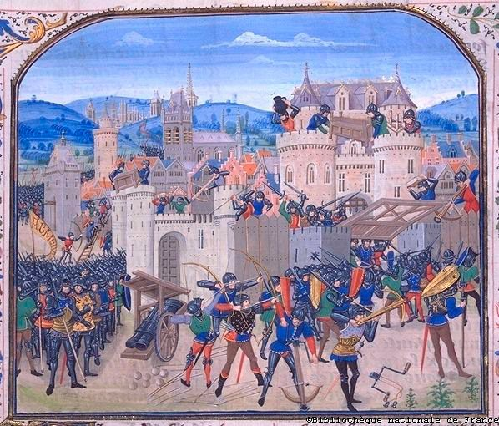As I’m sure you can imagine, sitting around calculating num- bers all day wasn’t the most exciting job, and this meant that these early computers were prone to errors (not at *all* like the modern computer!). To alleviate this problem, inventors came up with various mechanical devices to aid computers with their calcula- tions. The abacus, Napier’s Bones, the slide rule, and the Pascaline (whose inventor, Blaine Pascal, would later have his name cursed by countless computer programming students) are all examples of the tools that helped computers compute (Figure 1.3).

Other tools were developed in the passing centuries, all the way up to the first all-electronic digital computing device, the great-great-granddaddy of the modern computing world, the Electronic Numerical Integrator and Calculator, also known as ENIAC (Figure 1.4). Eventually, the calculating machine itself became known as a computer. Computers have gone through many refinements since the days of ENIAC, bringing us up to the wired world we now live in.

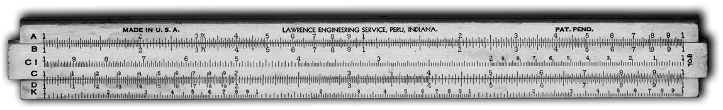

*Figure 1.3: Slide rule*

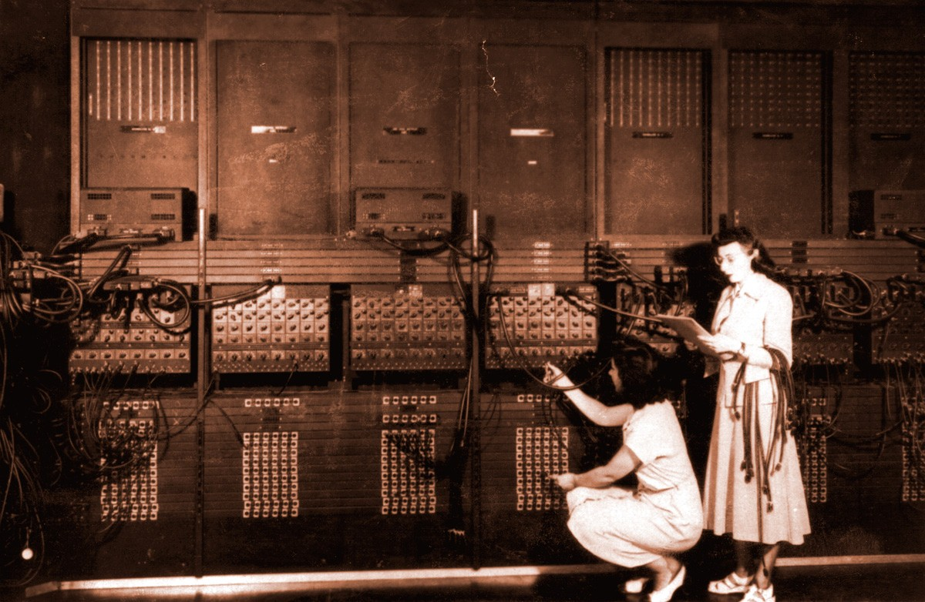*Figure 1.4: ENIAC (Photo courtesy of the U.S. Army)*



*You’ll also hear people refer to applications as* programs*, a term synonymous with the sets of coded instructions that tell the computer hardware to perform specific tasks, like add num- bers, create text documents and graphical images, play music, and more.*

**Computer Anatomy 101: Hardware and Software** At its most basic, a modern computer consists of three major components: hardware, operating system, and applications. The *hardware* is the stuff you can kick, like the keyboard, mouse, monitor, and case, plus all the pieces inside the case (Figure 1.5).

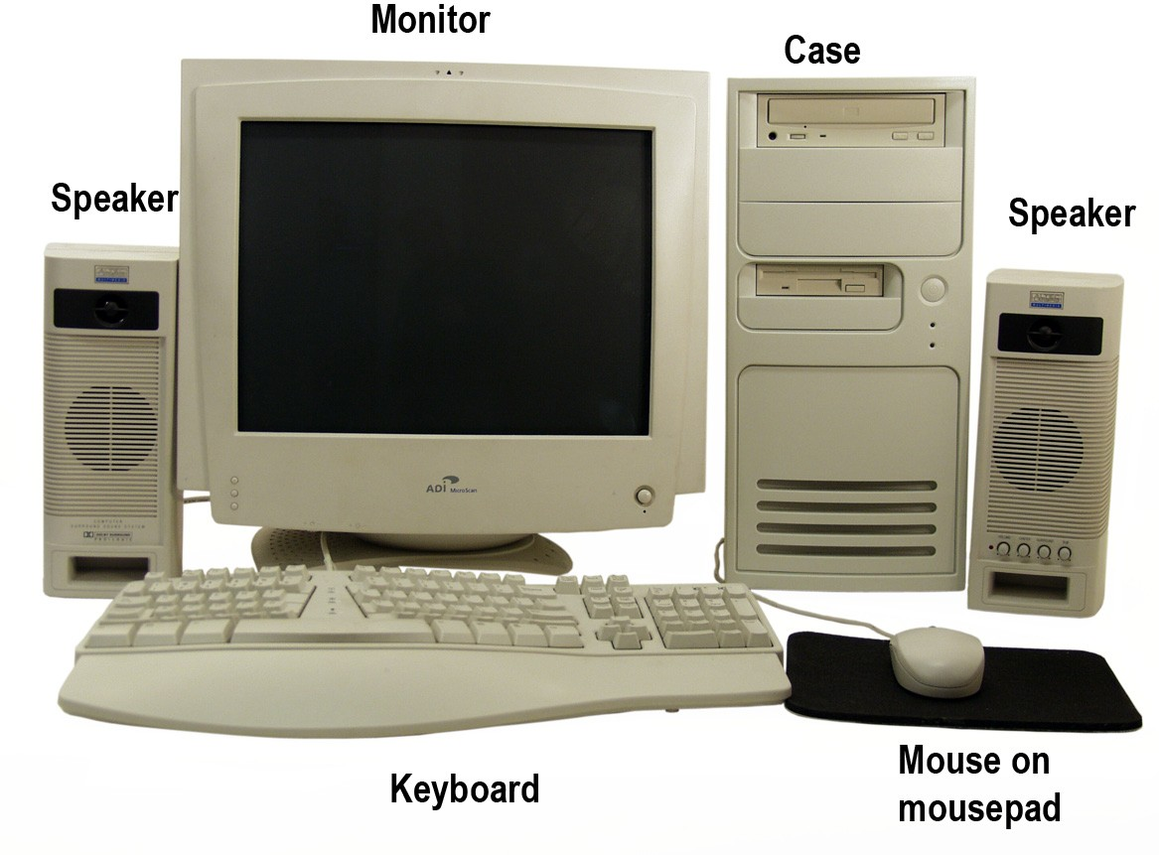

*Figure 1.5: Typical computer*

The *operating system* controls the hardware and enables you to tell the computer what to do. The oper- ating system often manifests as a window on the moni- tor that has little icons you can click (see Figure 1.6), but modern PCs are able to respond to other ways of giving commands, such as voice-command.

*Applications* enable you to do specialized tasks on a computer, such as type a letter, send a message from your desk to your friend’s computer in Paris almost instantly, or wander through imaginary worlds with people all over the Earth (Figure 1.7). Most com- puter users lump operating systems and applications together under the term *software*.

## How Computers Work

Computers work through a three-stage process: input, processing, and output. You initiate the action by doing something—clicking the mouse or typing on the key- board; this is *input*. The parts inside the case take over at that point, with the operating system telling the hard- ware to do what you’ve requested. This is *processing*. In fact, at the heart of every computer is the *central process- ing unit* (CPU), usually a single, thin wafer of silicon and microscopic transistors (Figure 1.8). The CPU handles the majority of the processing tasks.

Once the computer has processed your request, it shows you the result by changing what you see on the monitor or playing a sound through the speakers. This is *output*. Acomputer wouldn’t be worth much if it couldn’t

*Figure 1.6: Microsoft Windows XP operating system*

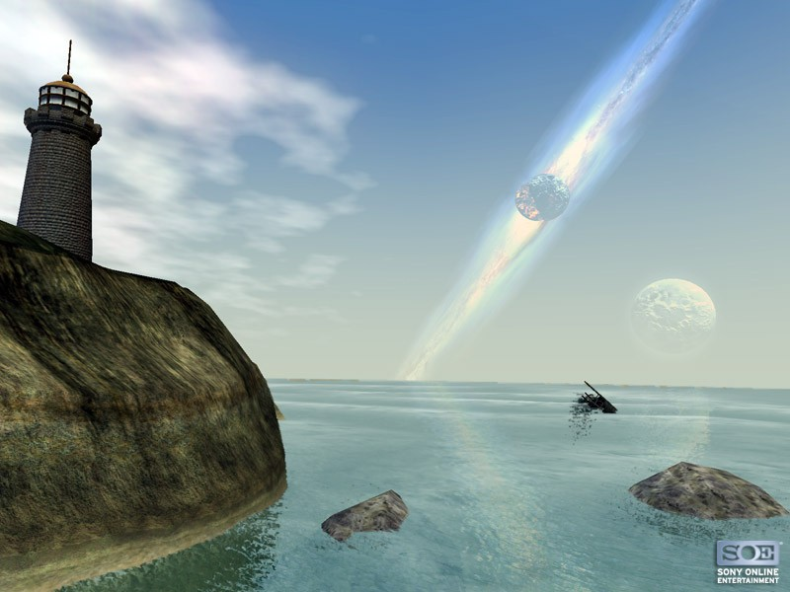

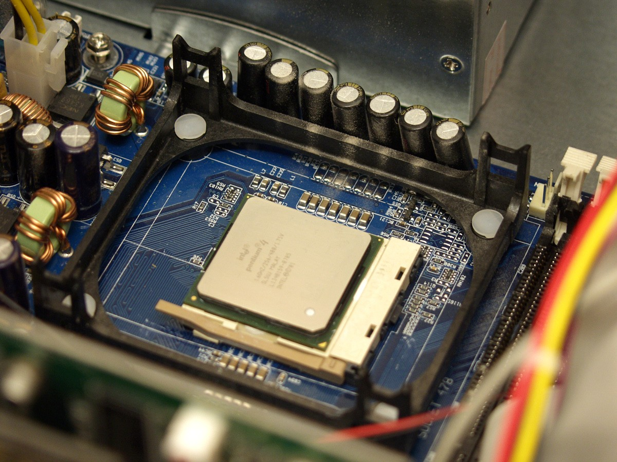*Figure 1.7: Wandering around in EverQuest II, a massively multiplayer online game (Courtesy of Sony Online Entertainment)*

I handle the output, changing what you see.

*Figure 1.8: Intel Pentium 4 CPU in motherboard*

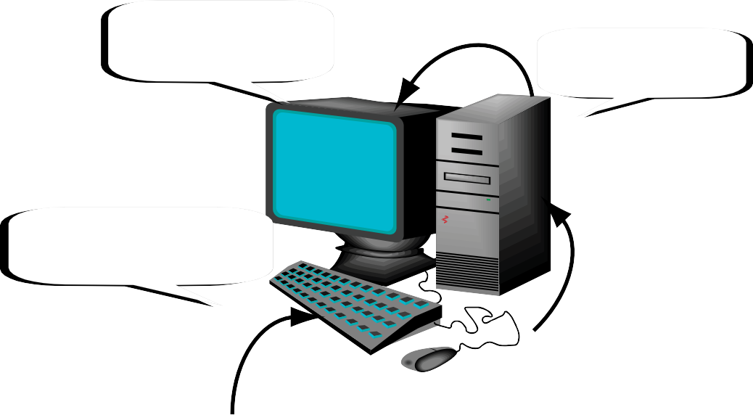*To Output*

All the processing takes place in here

demonstrate that it ful- filled your commands! Figure 1.9 shows the computing process.

We’ll go into the

Type on me or click the mouse to provide input

*Figure 1.9: The computing process*

details of each stage of the computing process throughout the rest of the book. The next few chapters hit the hardware in detail; chapters 5-7 give you an overview of operating systems; and chapters 8-10 delve into the arcane world of applica- tions. But wait, that’s not all! Parts 2 and 3 of this book cover applications in gory detail. For now, though, let’s go computer spotting.



**Saving**

*An important part of the computing process is* data storage*—saving a permanent copy of your work so that you can return to it later for further editing. Putting data storage in the context of the three-part computing process, you tell the computer to save something; the CPU processes that command and stores the data; the computer then often shows you something, such as a*

*message saying that the data is stored. Storing data is something that you do while you’re engaged in your other data processing activities, like writing a letter, editing a video, or playing a game. Any work that you don’t make a point of saving is lost when you turn the computer off. Chapter 2, “Going with the Data Flow,” goes into more detail about saving data.*

# *Categories of Computers*



**Modern Mainframes**

*Ready to buy? Mainframes aren’t in as big demand as they once were, so there are few manu- facturers. IBM and Unisys are two of the remaining makers*

*of mainframe systems. As I’m sure you can imagine, main- frame systems are fantastically expensive, running up into the hundreds of thousands of U.S. dollars (and you don’t even get a free printer!).*

When it comes to categories of computers, one size doesn’t fit all. Computers come in a wider variety of forms than just about any other device that you can name. This section describes the main categories of computer types.

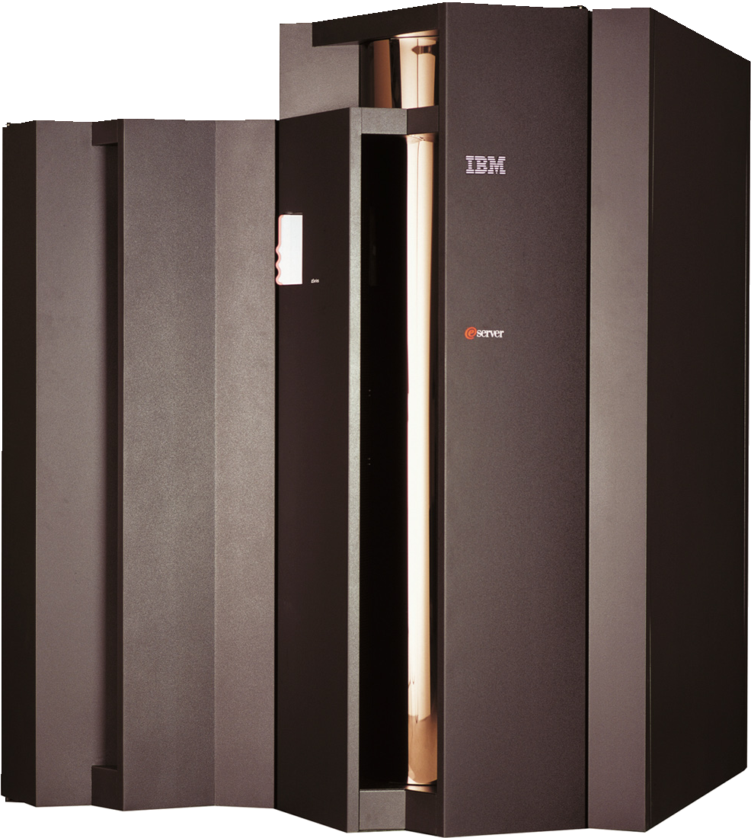**Mainframe Computers** From their introduction in the 1940s up until around the disco 1970s, mainframes dominated the computer world. *Mainframes* are mas- sively powerful computers, widely used in the academic, banking, industrial, and sci- entific fields. Mainframes specialize in multitasking, supporting dozens, hun- dreds, or even thousands of user sessions at the same time, with each user run- ning his own programs and working with his own files all at once. If you’ve seen any sci-fi movies from the

1950s, then you know what mainframe computers look like. Gigantic, boxy things

*Figure 1.10: Mainframe computer*

with lots of blinking lights and switches and spinning reels of magnetic tape (the data storage media of the time). They’ve gotten sleeker since then (see Figure 1.10), but mainframes are still physically large machines that range from roughly refrigerator-sized to being big enough to take up an entire floor of an office or school building.

## Supercomputers

*Supercomputers* harness the power of a mainframe computer and focus it on performing a single task, making them arguably the most powerful comput- ers on the planet. Most supercomputers manifest as a single large machine that has hundreds or thousands of CPUs working in tandem. These are the types of computers that you turn to when you need to perform big-brained tasks like tally census results, compile geothermal imaging data, predict how seismic activity will affect nuclear storage facilities 10,000 years down the line, or determine the answer to life, the universe, and everything.

Not all supercomputers are used strictly for higher purposes, however. One of the more common uses of supercomputers these days is rendering the sophisticated *computer generated imagery* (CGI) effects for movies. For example, the digital effects team for the Lord of the Rings trilogy used a supercomputer that had over three thousand CPUs to create the Oscar-winning special effects sequences. Guess it’s cheaper than hiring a *real* army of orcs.

## Minicomputers

Not many organizations need (or can accommodate) the computing muscle of a mainframe system, so in the 1960s computer makers developed the mini- computer. Essentially a scaled-down mainframe system, *minicomputers* could

be squeezed into a spare office or large storage closet instead of needing their own special space (Figure 1.11). Minicomputers find usage in many of the same fields as mainframes, plus they’re extensively used in telecommunications, the aviation industries, and others.



**Supercomputer Power on a Budget**

*A couple of years back, scientists at Virginia Polytechnic Institute & State University created the “Big Mac,” a supercomputer comprised of over a thousand*

*off-the-shelf Apple Macintosh G5 computers clustered together.*

*Not only did it work, but at the time, it was ranked as the world’s second fastest supercomputer!*

Like mainframes, minicomputers service many user sessions at once.

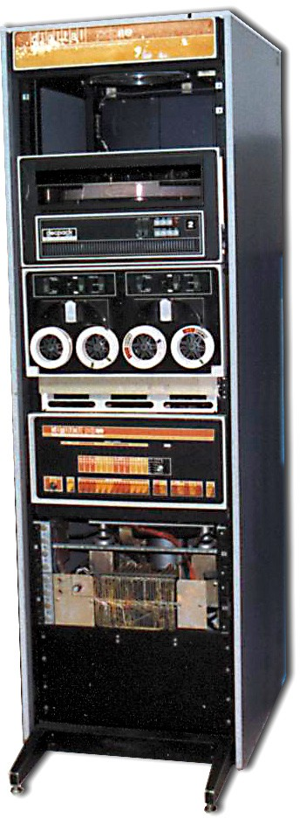Minicomputers are expensive, but nowhere near the cost of a mainframe—running in the tens of thousands of dollars instead of hundreds of thousands. Modern minicomputers are seeing more competition from high-end microcomputer systems, but still have a large *installed base*, meaning that there are a lot of them chug- ging away in offices and schools all over the world that aren’t in need of replacement anytime soon.

## Microcomputers

Now we get to the classic machine that we all know and love, the *microcomputer*—or as it’s better known, the *personal computer* (PC). Dating back to the 1970s, the PC is the machine that truly revolutionized the computer world. From its humble beginnings as a home-built gadget for the supergeek electronics hobbyist, the PC is now a fixture in practically every

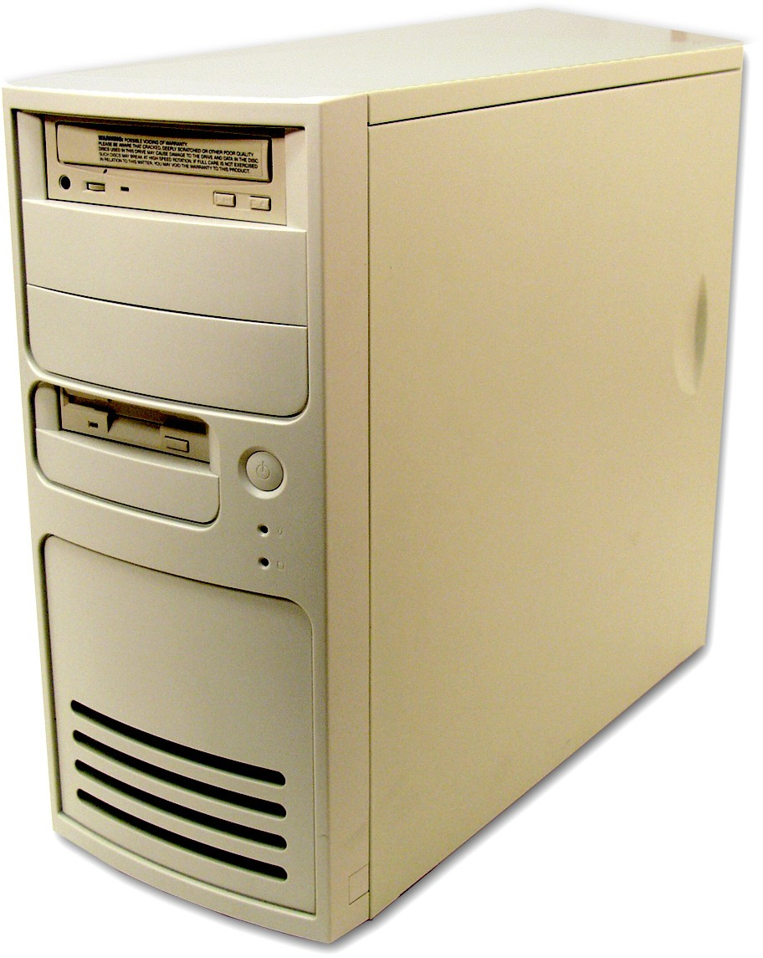school, business, and home.

PCs are called “personal” because

they were originally made to service only a single user session at a time. PCs come in two main physical con- figuration types, desktop systems and portable systems. Desktop PCs come in many shapes and sizes, from the

*Figure 1.11: Minicomputer (Photo courtesy of David Gesswein’s www.pdp8.net)*

basic suitcase-sized, putty-colored metal box that you’ve seen in offices, schools, and homes everywhere (see Figure 1.12) to exotic-looking creations with neon lights, custom paint jobs, and other stylistic touches (Figure 1.13).

Portable systems, as the name implies, are made to be mobile, and therefore smaller and lighter than desktop sys- tems. Figure 1.14 shows a typical portable computer. Portables

are usually called *laptop computers* or *notebook computers*.

PCs are the most widely ranging computers in terms of perfor- mance, varying from the bare-bones system capable of nothing more

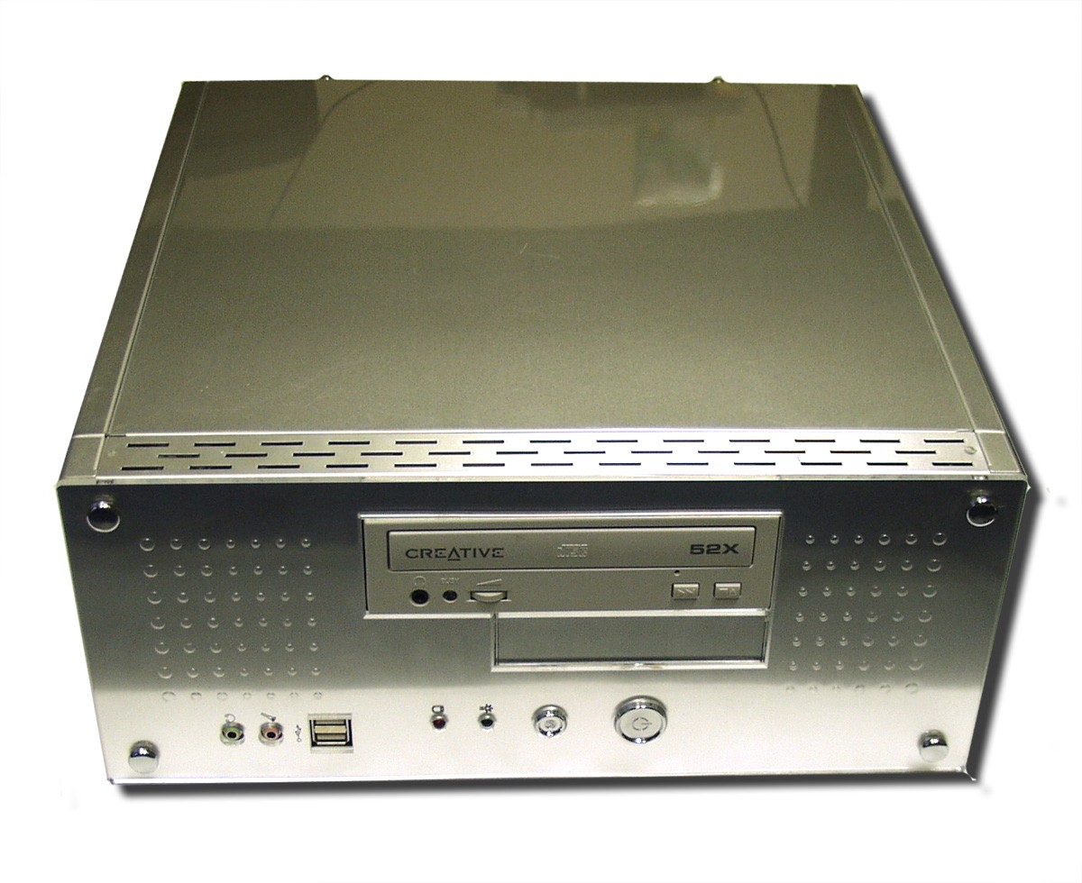

*Figure 1.13: Racy PC*

*Figure 1.12: Putty PC*

serious than browsing the Internet to systems that rival minicomputers in pro- cessing power. These high- end PCs are usually called *workstations*, although the term is also used to describe any system connected to a computer *network*—a struc- ture that enables computers to communicate with each other and share data and resources.

Some PC systems are also configured to fulfill specific roles on computer networks such as storing and sharing data or applica- tion programs from a central location, or providing net- work services such as e-mail

*Figure 1.14: Compaq laptop*

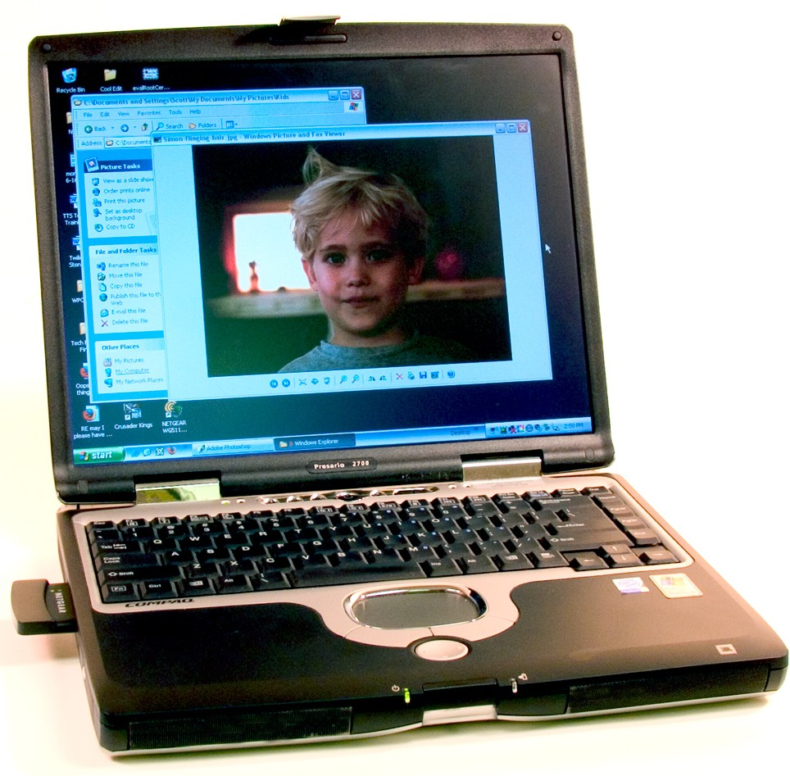

*The IC3 exam focuses mainly on microcomputer systems, so these are the types of systems*

*that I’ll focus on throughout this book.*

and printing. These specialized systems are called *servers*—as in file servers, application servers, mail servers, print servers, and so on. PCs that receive services from server systems are called *clients*.

Microcomputers come in several flavors, but the two most common in the wild are the IBM-style PCs and Apple Macintosh. They differ in both hardware and operating systems. Let’s take a quick look.

## IBM-style PCs

IBM-style PCs comply with the original PC hardware standards created by IBM back in the 1980s, although of course they’ve been updated over the ensu- ing decades. IBM-style PCs aren’t limited to those actually made by the IBM company, but can be made by Dell, HP, Sony, or any other manufacturer. IBM- style PCs—I’m going to call them PCs from here on out—are by far the most common type of computer you’ll see in the field. Figures 1.12, 1.13, and 1.14 show examples of typical PCs

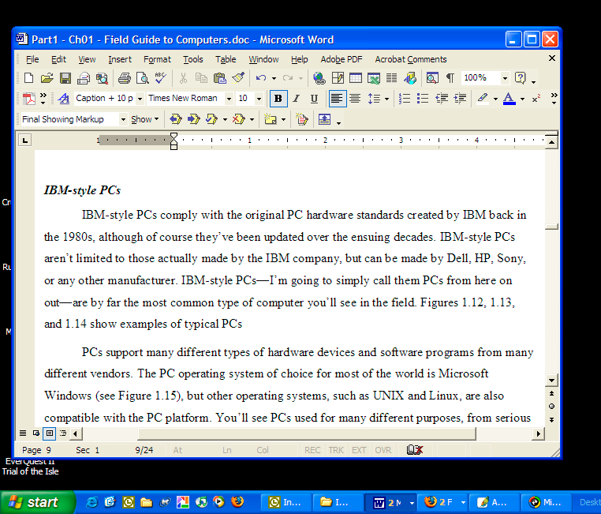PCs support many dif- ferent types of hardware devices and software pro- grams from many different vendors. The PC operating system of choice for most of the world is Microsoft Windows (see Figure 1.15), but other operating sys- tems, such as UNIX and Linux, are also compatible with the PC platform. You’ll see PCs used for many dif- ferent purposes, from seri- ous business applications to gaming, multimedia, and entertainment.

*Figure 1.15: Windows XP*

## Apple Macintosh



**PC and Mac Crossbreeding**

*Apple has announced plans to switch from their current hardware platform to the Intel*

*platform used by IBM-style PCs.*

*The switch won’t take place for awhile, however, so for the purposes of the IC3 exam, re-*

*member that Macs and PCs use different hardware standards.*

The *Apple Macintosh* computer—or *Mac*, as they’re usually called—has been around even longer than the IBM PC, but has a smaller market share, which is a fancy way of saying that people don’t buy as many of them. Figure 1.16 shows a typical Apple Macintosh computer.

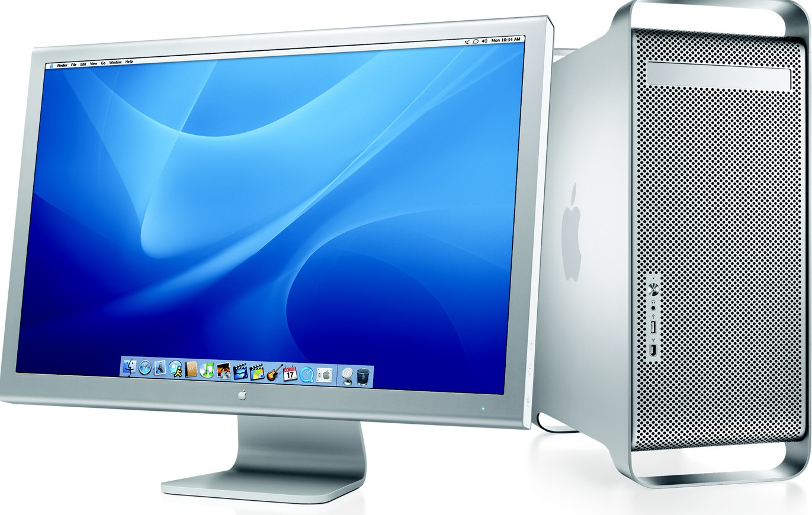Macs use their own internal hardware and software standards, although many programs and external devices work with both Macs and PCs, right out of the box. That statement is a bit deceptive, though. You might use the same CD-ROM to install an application like Adobe Photoshop

Elements on both a Mac and a PC, but the software developer actually puts two versions of the software on the disc!

Macs use the Apple oper- ating system, called *OS X* (Figure 1.17). Macs are capa- ble of tackling the same tasks that you’ll see PCs used for, but are typically used more in the creative fields, such as video editing and the graphic

arts.

*Figure 1.16: Apple Macintosh (Photo courtesy of Apple Computers)*

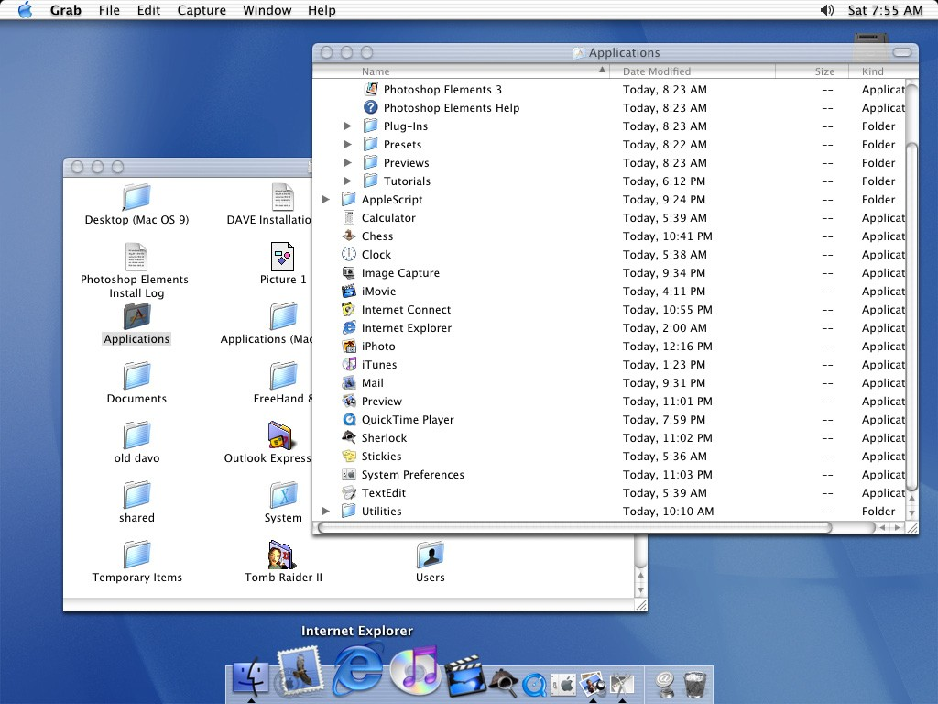

*Figure 1.17: OS X Desktop*



*The X in OS X is pronounced “ten” as in the Roman numeral, not “ex” like the letter or your former significant other.*

# *Handheld Computers and PDAs*

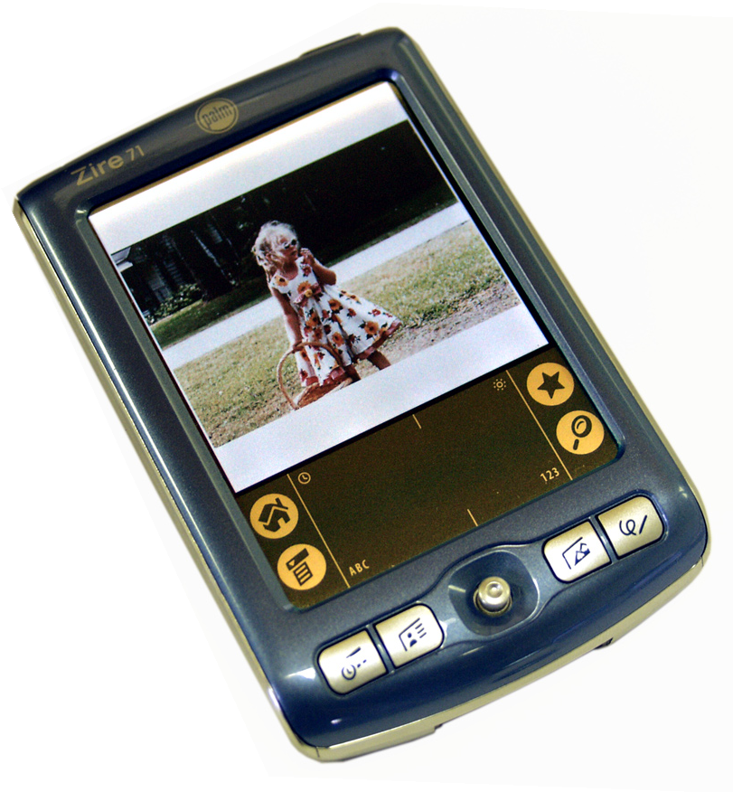

We humans are hand-oriented beings, so it was inevitable that we’d want to shrink computers down to something that we can hold in our hand like any other tool. Manufacturers produce multi-function and single-function *handheld computers*. The most popular example of the former is the *personal digital assis- tant* (PDA). PDAs help you stay organized by giving you a way to copy and carry around data that you’d normally store on your PC, such as your address book, calendar, task lists, and so on. Most even have enough processing power to enable you play games, edit text documents and spreadsheets, read books, listen to music, and do many other computing tasks on the go. PDAs

are divided between two popular platforms: Microsoft Windows Mobile (sometimes called PocketPC) and the Palm OS (Figure 1.18). Some spe- cialized PDAs run on Linux, the third major operating system family.

PDAs have a small built-in display screen that also acts as a data input device. Handwriting recognition software enables you to enter text by writ- ing on the screen with a pen-like instrument called a *stylus* (see Figure 1.19). Many also have small integrated keyboards: just the thing for the two-fingered typists of the world.

Some handheld computers and PDAs also double as communications devices. The RIM Blackberry, PocketPC Phone Edition, and Handspring Treo all combine data organizing functions with e-mail, Internet browsing, multi- media, and cellular phone capabilities (Figure 1.20). Gene Roddenberry would be proud!

Specialized or single-purpose handheld computing devices enable you to perform tasks that used to require extensive or bulky equipment. With an e-book reader, for example, you can carry around and read the equivalent of a small library full of books in your jacket pocket. Click a button and you’re “thumbing” through the latest bestseller. Digital music players, such as the Apple iPod, put a full-blown stereo system and your collection of audio CDs into a stylish, palm-sized package (Figure 1.21).

Finally, if number crunching is your thing, a modern scientific calcula- tor puts more raw processing power into a 3x5-card-sized shell than the first mainframes could boast (Figure 1.22).

*Figure 1.18: Palm*

*Zire 71 PDA*

*Figure 1.20: Treo 600 PDA/cell phone*

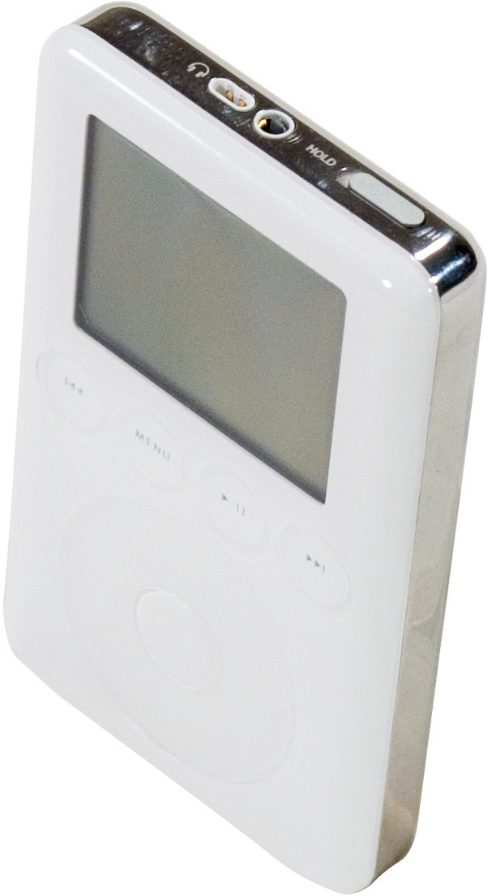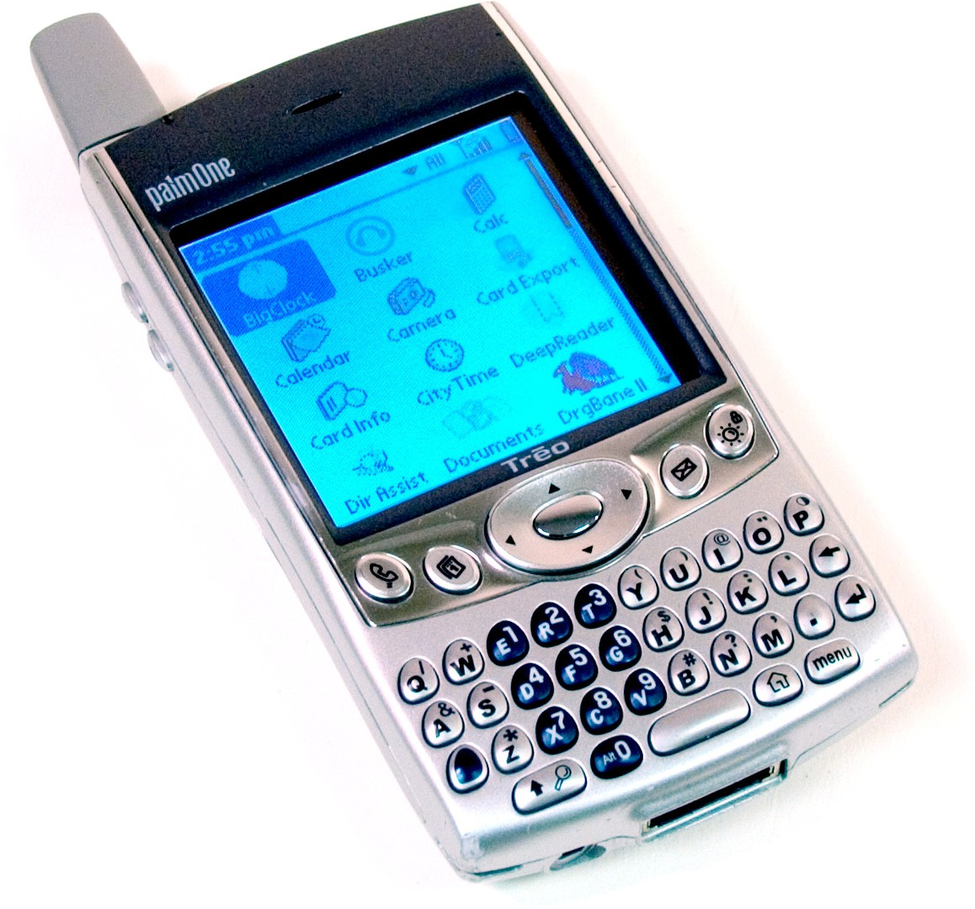

*Figure 1.21: Apple iPod*

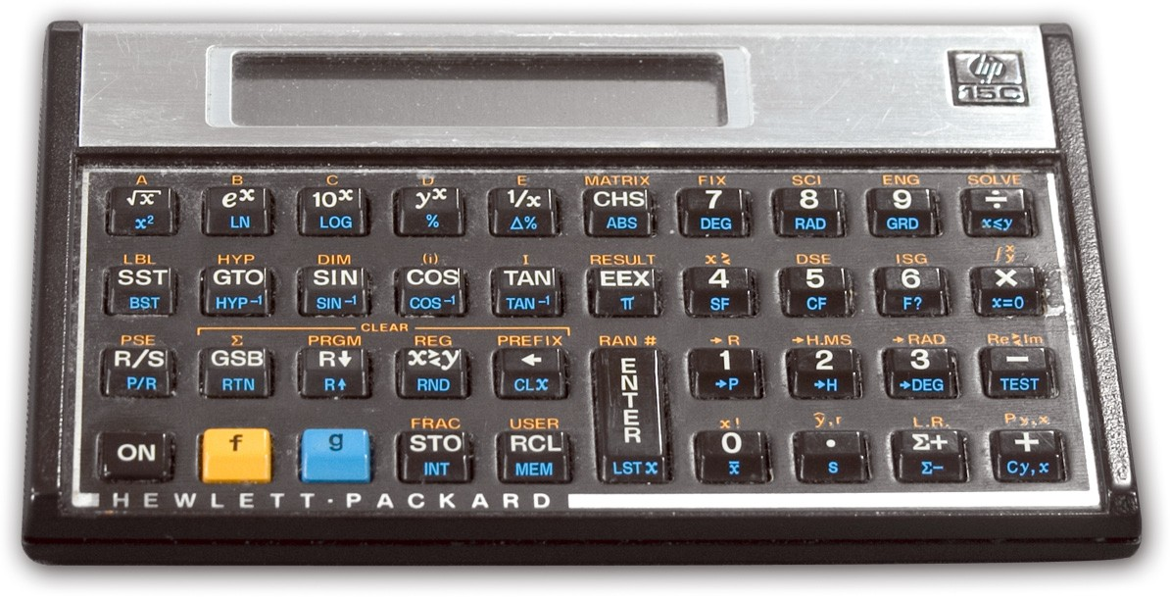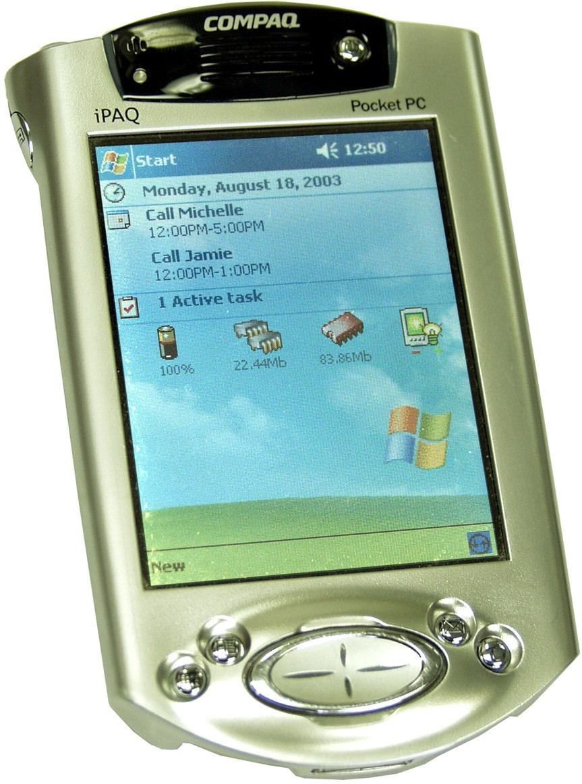*Figure 1.19: Compaq iPAQ PDA*

*Figure 1.22: Scientific calculator*

# *Connecting Computer Systems Large and Small*



**Rise of the Machines**

*Computing devices are in use everywhere in the real world. How many do you come across during the course of a normal day? List at least five examples of computers and computerized systems in use around you.*

*Where are they? What tasks are they being used for? Think beyond the obvious examples such as desktop PCs, and look for not-so-obvious examples such as computerized air conditioning systems, security systems, and so on.*

When you see a Chihuahua standing next to a Great Dane, it’s hard to believe that they’re both from the same species. By the same token, set a Mac mini next to a Cray supercomputer, and it’s hard to believe that they’re both computers, but it’s true. See Figure 1.23.

For all the differences between large mainframe and minicomputer systems and small microcomputer PC systems, the most important differ- ences lie in where the data processing takes place and where data is stored. Understanding these differences is the key to understanding how computer systems connect together and enable you to do cool things like share files with

friends around the world.

## Mainframe and Minicomputer Systems: Centralized Data Processing and Storage

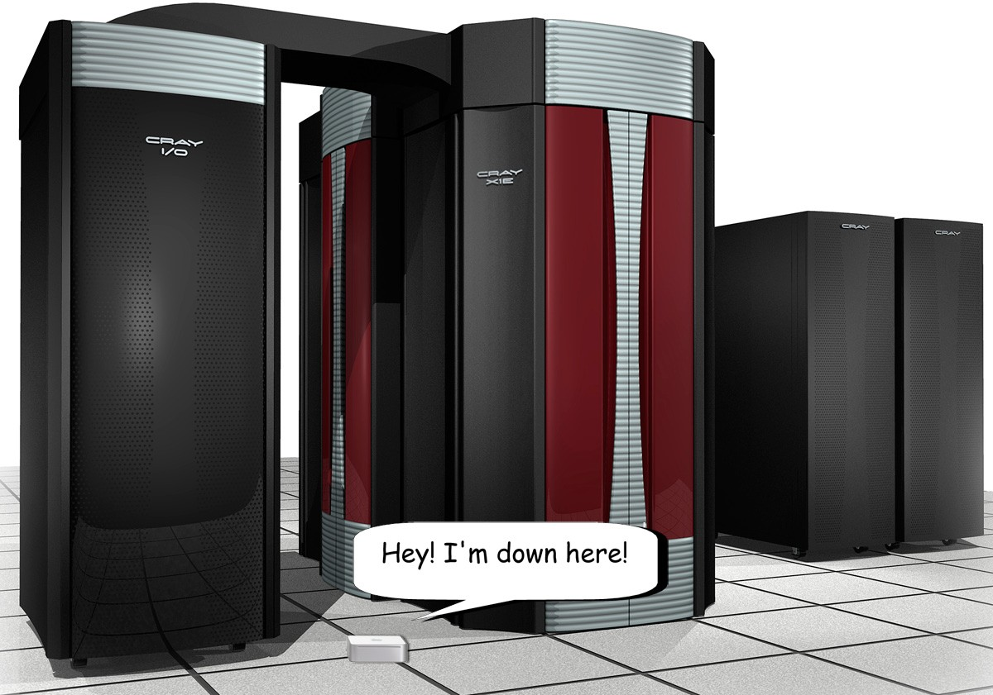Large computer systems like mainframes and minicomputers put all of their eggs in one basket, so to speak. All processing takes place directly on the centralized mainframe or minicomputer system, and all data and user account information is stored in one place. All users access the main system and run their programs. This is called *centralized processing*. Depending on the power of the large system, a single mainframe or minicomputer can service all users in the office building or school campus. Wherever the user may be, however, all of the power rests on the mainframe or minicomputer. Figure

1.24 illustrates mainframe and minicomputer systems.

Users connect to mainframe and minicomputer systems via two methods, dedicated input/output (I/O) stations called *terminals*, and through special terminal emulation software. The

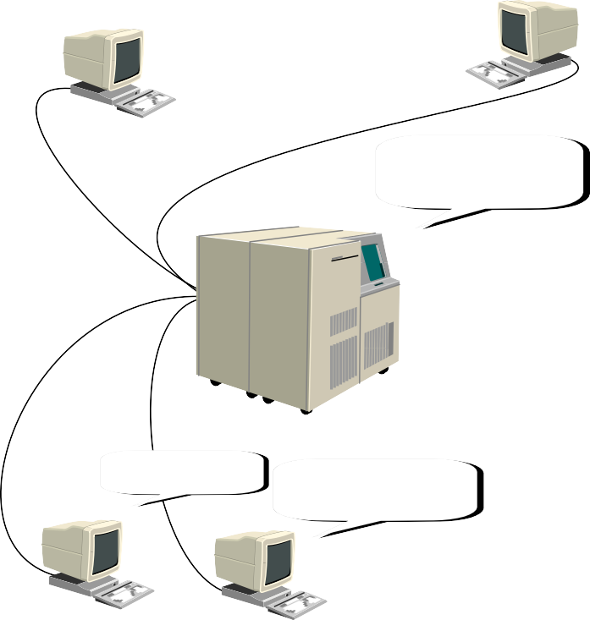

*Figure 1.23: Mac mini and Cray supercomputer*

I'm in Building A

I'm in Building B

**User 2**



**Not-So-Dumb Terminals**

*Dumb terminal hardware isn’t always* completely *dumb. Some dumb terminal stations have hardware that enables them*

*to connect to mainframe and minicomputer systems remotely, via telephone lines or other network structures. Even in these cases, however, dumb terminals are useless if they lose their connection to the mainframe or minicomputer.*

**User 1**

Seems like I'm the one doing all the work!

**Mainframe**

We're in Building C

But we can all work through the mainframe

**User 3 User 4**

*Figure 1.24: Typical mainframe*

*and user setup*

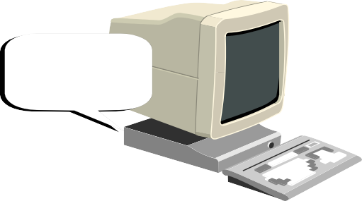

I'm not much more than a network card and a power button!

*Figure 1.25: Dumb terminal*



**Dumb Terminals**

**in the Modern World**

*Students often look at me funny when I talk about dumb terminals connecting to mainframes and minicomputers, won- dering why they should care about how computers worked before they were even born. The funny thing is, though, that VDTs are alive and well and in use all over the world. Bank teller stations are frequently simple I/O dumb terminals that enable tellers to access the bank’s central customer database stored on a mainframe computer. Many retail establishments like bookstores and grocery stores use dumb terminals connected to inventory software running on a minicomputer system. Just by knowing how these things work, you’re a step up on the competition!*

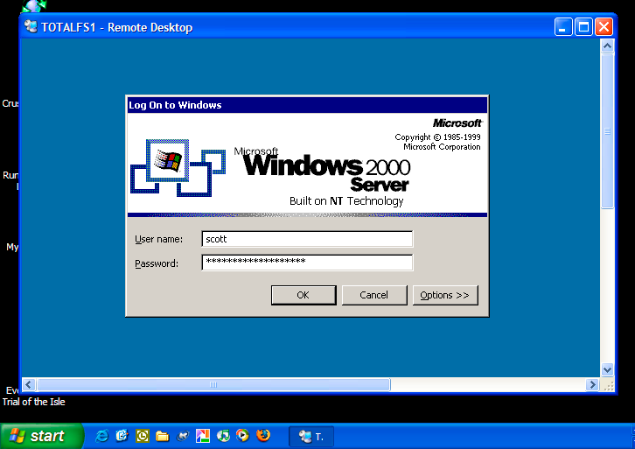*Figure 1.26: Windows Terminal Client (Remote Desktop)*

typical terminal—officially called a *video display terminal* (VDT) and unoffi- cially called a *dumb terminal*—consists only of a keyboard, a display monitor, and a very simple device to make the connection to the mainframe (Figure 1.25). They’re called “dumb” because these I/O stations don’t use any comput- ing power or storage capacity of their own—they’re used only to

connect to the mainframe or minicomputer system.

Microcomputers can act as client systems for main- frame and minicomputer systems via *terminal emulation software*—programs that duplicate the functionality of

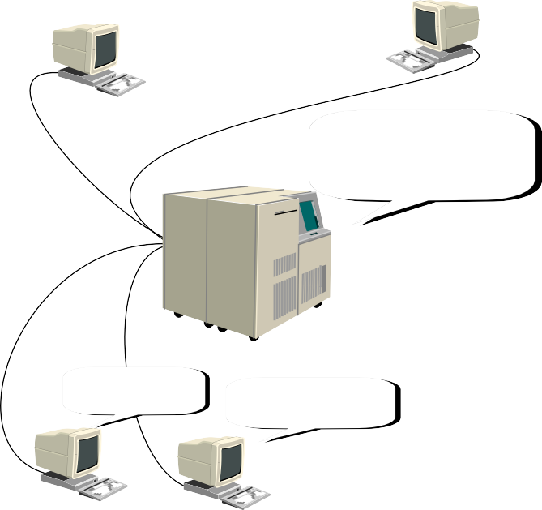

I can't work at all!

dumb terminals. Yes, it’s kind of funny to have the power of a modern microcomputer devoted to acting like a brainless VDT, but there you go. The latest versions of Windows and OS X have termi- nal emulation software built right into the operating

system, and there are many third-party versions of ter- minal software available (Figure 1.26).

Centralized processing and storage has the advantage of being, well, *centralized*. There’s never any question of where the computer hardware and data resides. This makes it easy to perform administrative tasks like troubleshoot hard- ware problems, manage user accounts, and back up

data. The disadvantage is that the central computer system becomes your single point of failure. If the mainframe or minicomputer goes down, nobody

**User 1**

Hey! What gives?

**User 2**

I store all the data and provide processing power, but when I'm down? Just look at the poors saps!

**Mainframe**

can get to their programs or data. See Figure 1.27. Mainframe and minicomputers typically have redundant hardware components to prevent total system failure in case of a problem. This is called *fault tolerance*.

Oh great. The server must be down again!

**User 3 User 4**

Ruined! Ruined! We'll never get this finished!

*Figure 1.27: Advantages and disadvantages to centralized processing and storage*

*Figure 1.28: Decentralized processing*

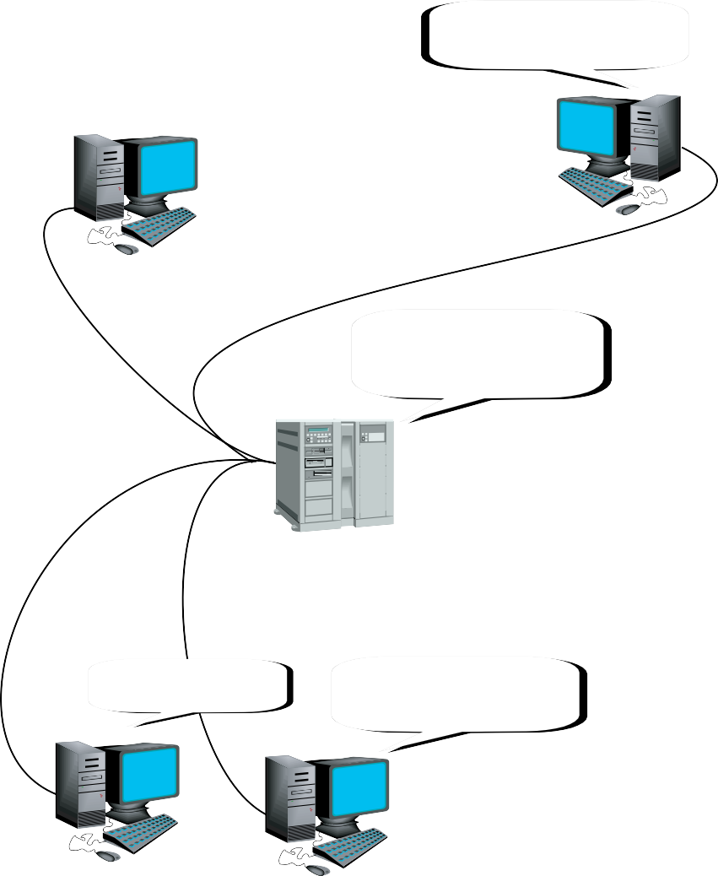

Who needs a mainframe?

#### User 1

Yeah. I've got everything I need right here.

#### User 2

**Microcomputer Systems: Decentralized Data Processing, Flexible Storage, Sharing**

In contrast to the centralized scheme of large mainframe and mini- computer systems, microcomputer systems bring their own processing power and storage capacity to the table. Each microcomputer is in charge of its own user accounts, application

programs, data files, and hardware (Figure

#### Server

Don't look at me that way! I just store data!

1.28). This is called *decentralized processing*.

This decentralized organization enables a great deal of flexibility. Microcomputers can be linked together in a computer network. In a net- work environment, processing power is still in the hands of each networked PC, but data storage can be centralized on a single PC called a file server. As with the centralized data storage scheme of mainframes and microcomputers, this makes it easier to manage and back up the data files.

We're in Building C And we can do work even

if the server goes down.

***Networks***

Networks come in a couple of flavors, named to describe their location and scope. *Local area net- works* (LANs) connect computers to each other in a single physical location, such as a school, office,

#### User 3 User 4

or home. Two or more LANs connected together form a

*wide area network* (WAN).

Computers in a LAN are connected by network cables and hard- ware devices called *hubs* or *switches* (Figure 1.29). Some networks use radio waves instead of physical *network cabling* to connect PCs to each other, creating *wireless networks*. Computers on these wireless networks are usually linked together by a special wireless hub called

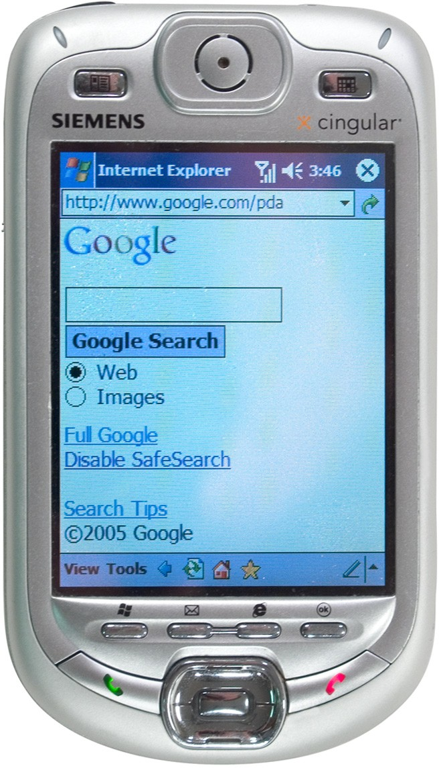a *wireless access point* (WAP).

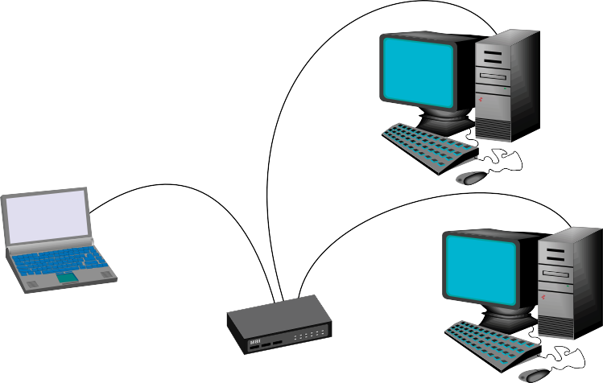WANs generally manifest as a collection of LANs in multiple buildings or multiple cities, which is why you’ll occasionally hear them described as *remote networks*. The best example of a remote network is the Internet—a worldwide network of remote networks connected by a series of high-speed communica- tions lines (Figure 1.30). Other examples of remote

networks are school or office networks that enable you to connect to them from home or from on the road.

Single microcomputers and LANs connect to WANs such as the Internet through hardware devices

called *routers*. Routers come in both wired and wire- less models.

*Figure 1.31: PDA surfing the Net*

*Figure 1.29: Typical LAN*

**Switch**

*Figure 1.30: Typical WAN*

Routers send net- work communica- tions out through regular telephone lines, digital sub- scriber lines (DSL), cable television lines, or through special dedicated network cabling structures with exotic-sounding names like ISDN, T1, T3, and so on.

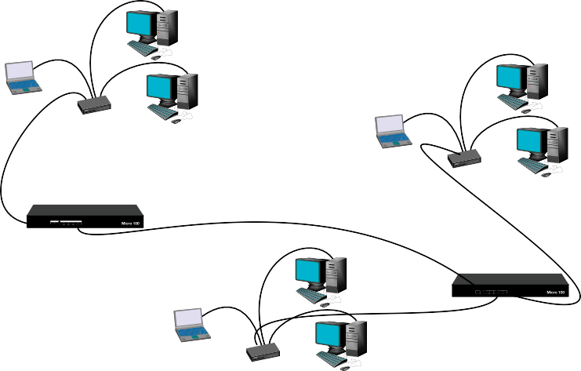

**Router**

**Router**



**Distributed Computing**

*Multiple computer systems can share their processing power to perform a single computing task, a process called* distrib- uted computing*. Distributed computing involves spread- ing out the workload among multiple computers at different times instead of all at once; and if done right, can turn a collection of microcomputers into the functional equivalent of a supercomputer—at a fraction of the cost.*

*One example of this pro- cess is the SETI@home project. The SETI (Search for Extrater- restrial Intelligence) organiza- tion maintains a huge array of satellite receivers at the Arecibo observatory array in Puerto Rico. This array collects tons*

*of data gathered from space. Volunteer computers called nodes take small chunks of raw data and process it into results that are then passed back to the project’s central server for compilation. So far, no extrater- restrial life has sent any clear messages, but the SETI folks are still watching the skies.*

In our increas- ingly wired world, you’ll also

find handheld devices such as PDAs and cell phones that can connect to the Internet through a router. Even advanced gaming consoles, such as the Xbox 360 and PlayStation 3 offer Internet connectivity, although for the specialized purpose of smacking your friends and neighbors in computer games online.

### *Sharing Resources*

The decentralized nature of microproces- sor networks enable computers to share storage space, printers, scanners, application programs, and in special cases they can even share CPU processing power. Sharing these devices saves you money, because instead of installing, say, ten separate printers on ten separate computers on your network, you can instead have them each share a single printer installed onto just one computer. All modern operating systems enable you to share resources with a mere mouse click or two (Figure 1.31).

*Figure 1.31: Sharing a folder in Windows XP*



**Synchronizing PDAs and Microcomputers**

*PDAs enable you to tote your important data and documents around and work on the go, but how*

*do you pass this data from the PC to the PDA and back again? You transfer data between your PDA and PC through a process called* synchronizing*. Synchronizing your PDA and computers keeps the shared data consistent. Synchronizing is also how you install new application software onto your PDA.*

*Synchronizing your PDA to your PC requires a hardware connection between the two systems and special synchronizing software to control the process. Typically, your PDA connects to the computer through a synchronizing cable or cradle. Some PDAs also enable you to synchronize through a wireless network connection or via an Infrared port. Once connected, running the synchronizing software updates the files that are stored on both devices, saving the most recent version.*

## It’s a Wired World

CHAPTER 1:

* Computers are everywhere: in our homes, offices, businesses, schools, and libraries. Every modern car has a computer or two. You’ll find computers controlling manufac- turing facilities throughout the world. Even clocks have computers!
* Ancient “computers” were people who crunched numbers all day, and various devices like the abacus and slide rule helped them do their jobs.
* A modern computer consists of three major components: hardware, operating system, and applications. The keyboard, monitor, and components inside the case (like the CPU) are typical hardware. Windows and Macintosh operating systems provide an interface for you to tell the computer what to do and then control the hardware. Applications or pro- grams enable you to accomplish specialized tasks, such as word processing and gaming.

SUMMARY

* Computers work through a three stage pro- cess: input, processing, and output. You provide the input; the CPU and other com- ponents process your request; the operating system sends output to the monitor, speak- ers, or storage medium to let you know the outcome of your request.

## Categories of Computers

* Mainframes are massively powerful comput- ers, widely used in the academic, banking, industrial, and scientific fields. Mainframes specialize in multitasking, supporting dozens, hundreds, or even thousands of user sessions at the same time. Supercomputers rival mainframe power, but focus on spe- cialized tasks, like rendering movie special effects.
* Minicomputers work much like mainframes, enabling many people to connect and work at the same time, but at a much lower price.
* Microcomputers generally serve a single user

at a time and come in two packages, desktop systems and portables. The most common types of microcomputers are the IBM-style PC and the Apple Macintosh. IBM-style PCs use Intel or AMD CPUs—called x86 architec- ture—and run Microsoft Windows operating systems, for the most part. The Macintosh uses Motorola or IBM Power PC proces- sors—called the G4 or G5—and runs the Mac OS X operating system.

* Handheld computers offer scaled down versions of microcomputers—multifunc- tion devices such as PDAs and PDA/cell phones—or very specialized tasks, such as media players like the iPod and scientific calculators.

## How Computer Systems Integrate

* Large computer systems like mainframes and minicomputers use centralized data pro- cessing and storage. Users connect to main- frames and minicomputers through dumb terminals that have no computing power of their own, and through terminal emulation software running on microcomputers.
* Smaller systems like microcomputer net- works use decentralized processing and stor- age. Through networks, computers can share resources such as files, folders, and storage space, printers, scanners, and applications
* Microcomputers connect to each other through local area networks (LANs) using network cables and hubs or switches, or radio waves and wireless access points (WAPs). Microcomputers and LANs con- nect to remote, wide area networks (WANs) through routers.

**16**

**16**

COMPUTER LITERACY: YOUR TICKET TO IC3 CERTIFICATION

## Key Terms

Apple Macintosh

Central processing unit (CPU) Centralized processing Cluster

Decentralized processing Distributed

Handheld computer Hub

IBM-compatible personal computer (PC) Local area network (LAN)

Macintosh OS X Mainframe Microcomputer Microprocessor Microsoft Windows XP Minicomputer

Network cable Remote Resource Router

Server Service Sharing Storage

CHAPTER 1:

Supercomputer Synchronizing

Personal digital assistant (PDA) Terminal emulation

Video display terminal (VDT),

REVIEW

a.k.a. dumb terminal Wide area network (WAN) Wireless access point (WAP)

## Key Term Quiz

Use the Key Terms list to complete the following sentences. Not all the terms will be used.

1. Users access mainframe and minicom- puters through I/O stations called

.

* 1. computers support

thousands of user sessions at a time, and are frequently used in the academic, banking, industrial, and scientific fields.

* 1. A is a small computing device that enables you to carry your contact lists, calendars, and important documents and extend the use of your PC.
  2. A is a group of comput-

1. Most IBM-style PCs use for an operating system.
2. Most Apple computers use for an operating system.
3. Data shared between a PC and a PDA is kept current by .
4. A local computer network can connect to a

ers whose processing power is combined. through a router.

4. are frequently used in the telecommunications and aviation indus-

1. Microcomputers connect to mainframe and minicomputer systems using

tries, and support hundreds of user sessions software. at a time.

**17**

**17**

CHAPTER 1: FIELD GUIDE TO IDENTIFYING COMPUTERS IN THE WILD

## Multiple Choice Quiz

CHAPTER 1:

* 1. Which of the following was the first type of electronic computer?
     1. Mainframe computer
     2. Minicomputer
     3. Microcomputer
     4. Handheld computer
  2. How do microcomputer users gain access to mainframe and minicomputer systems?
     1. Stylus
     2. Dumb terminal
     3. Terminal emulation software
     4. Synchronizing
  3. Which of the following scenarios best suits minicomputer usage?

REVIEW

* + 1. A large banking institution that needs to give thousands of users access to a financial database at a time
    2. A small business that has to give 50 employees access to a folder of

shared text documents, graphics, and spreadsheets

* + 1. A digital effects company that needs to render 3-D CGI effects for a movie production
    2. A school that needs to give 400-500 research students access to a centralized scientific database at a time
  1. A friend asks for you to advise her in a computer purchase. She wants a way to maintain her daily schedule, take notes, and carry her contact list with her everywhere. What device do you recommend for her?
     1. Video display terminal (VDT)
     2. Desktop computer
     3. Portable laptop computer
     4. Personal digital assistant (PDA)
  2. Which of the following are types of connec- tions that routers can use to communicate? (Select all that apply.)
     1. Regular telephone lines
     2. Digital subscriber line (DSL)
     3. Virtual private network (VPN)
     4. Cluster
  3. Which of the following operating systems will run on the standard IBM-compatible PC platform? (Select all that apply.)
     1. Apple OS X
     2. Microsoft Windows
     3. Amiga OS
     4. UNIX/Linux
  4. What device does a microcomputer or LAN use to connect to a WAN, like the Internet?
     1. LAN-to-WAN adpater
     2. Cable booster
     3. PDA
     4. Router
  5. What do you call a computing method in which a large processing job is broken up into smaller jobs and deployed to numerous computers?
     1. Packet computing
     2. Distributed computing
     3. Synchronized computing
     4. Decentralized computing
  6. Mainframe computers enable thousands of users to run programs and access data all at the same time. Where does the actual processing take place?
     1. The user’s video display terminal (VDT)
     2. The mainframe computer
     3. The network adapter
     4. The software applications
  7. A family member currently uses an IBM- compatible PC running Microsoft Windows. He is thinking of switching to an Apple Macintosh computer running OS X. What are some potential pitfalls to switching from one platform to another?
     1. He’ll have to replace his Windows sofware application programs with versions written for OS X.
     2. He’ll face a steep learning curve for the new operating system.
     3. A Macintosh system won’t be as stable as a Windows system.
     4. A Macintosh system won’t be as fast as a Windows system.

**18**

**18**

COMPUTER LITERACY: YOUR TICKET TO IC3 CERTIFICATION

## Essays

CHAPTER 1:

* 1. All computers can perform which of the following tasks? (Select all that apply.)
     1. Receive input
     2. Store data
     3. Process data
     4. Support hundreds of user sessions at a time
  2. All computers have which of the following components? (Select all that apply.)
     1. Central processing unit (CPU)
     2. Scanner
     3. Operating system
     4. Storage devices
  3. What kind of computer is dedicated to performing a single, complex processing task such as compiling geothermal data and rendering 3-D animation?
     1. Mainframe computer
     2. Minicomputer
     3. Microcomputer
     4. Supercomputer
  4. What is the advantage of linking comput- ers together in a network? (Select all that apply.)
     1. Ability to share storage space
     2. Ability to share hardware like printers and scanners
     3. Ability to share processing power
     4. There’s no advantage.

1. Computing devices are widely used in industries such as transportation, commu- nication, and entertainment. Name at least one computing device for each category, and describe how they are used.
2. Briefly describe the general uses for main- frame computers, minicomputers, micro- computers, and supercomputers.
3. Describe the differences between centralized and decentralized data processing.

## Projects

REVIEW

1. Visit the Computer History Museum Web site at [http://www.computerhistory.org](http://www.computerhistory.org/) and research how computers have evolved in the time you’ve been alive. What impor- tant computer technologies have been invented in that time? What were comput- ers like when you were born?
2. As an example of how distributed comput- ing works, visit the SETI@home Web site at [http://setiathome.ssl.berkeley.edu](http://setiathome.ssl.berkeley.edu/) and view the FAQ. How does the project work? What is required for you and your com- puter to participate?

**19**

**19**

* 1. What do you call the process by which you update data between a PC and a PDA?
     1. Clustering
     2. Distributed computing
     3. Synchronizing
     4. Terminal emulation

CHAPTER 1: FIELD GUIDE TO IDENTIFYING COMPUTERS IN THE WILD

**20**

**20**

COMPUTER LITERACY: YOUR TICKET TO IC3 CERTIFICATION